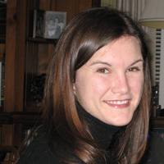

https://uci.academia.edu/AnnessaStagner
Annessa Stagner graduated with a Ph.D. in History from University of California, Irvine in 2014 after completing an MA in Contemporary History at Ohio University and BA at West Texas A&M University. She is currently a Visiting Assistant Professor in UCI's Humanities Core Program. Annessa’s current work focuses on American understandings of shell shock during and after the First World War. She currently has two publications, one in the Journal of Contemporary History and a book chapter with Duke University Press. In addition to conferences, she has appeared on TEDx and CSPAN History TV.

